WAWA Shortie Hoagie Voucher
Spring Fundraiser
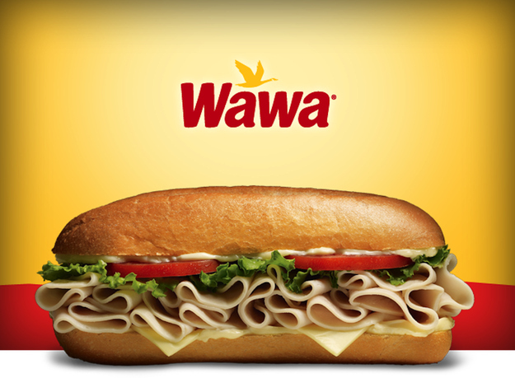
Place an order for Wawa Shortie Hoagie Vouchers today!! Each $4.00 voucher sold provides a $1.00 profit to the PJP Athletic Club. The PJPAC supports all PJP athletes and athletic programs. Simply complete the order form below and return it to the Main Office of the school in an envelope labeled “PJPAC WAWA Shortie Spring Fundraiser” by Friday, March 20th. Orders will be filled as received. Please include cash or check made payable to “PJP II High School”. Please detach and return form below with your payment.
_ _ _ _ _ _ _ _ _ _ _ _ _ _ _ _ _ _ _ _ _ _ _ _ _ _ _ _ _ _ _ _ _ _ _ _ _ _ _
Student Name: _____________________________
Sports team:________________ Student lunch period:___________
Number of vouchers _________ X $4.00 = Total Due $___________
E-Mail: __________________ Contact phone # _________________

